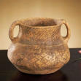
Yangshao Vases, 3rd millennium BCE,
- Mastery of pottery art at a very early date
- Along the yellow river valley
- Finely decorated earthen ware bowls
- Burial urns indicative of early ancestor worship
- Painted red and brownie black
- Some animal motifs but mainly abstract
- Interrelated curves, angles and geometric motifs

Statuettes from the Temple at Eshnunna, Iraq, ca.2700BCE
- Large eyes, exaggerated
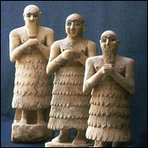
- Shows that vision is not simply a function but is something sacred
- How humans interact with the gods
- Function is that some return the gaze of the viewer and the others are facing the deity itself
- Static form reflects their position as perpetual worshippers
- Range in size to under a foot to 30 inches tall
- All represent mortals but are connected to deities
- Hands folded in gesture of prayer
- Usually holding small beakers that Sumerians used in religious rites
- Hundreds have been found in temple complexes at Eshnuna
- Men wear belts and fringed skirts and most have beards and shoulder length hair
- The women have long robes with right shoulder bare
- All have heads titled upwards
- They wait in the Sumerian waiting room for the divinity to appear
- Simple forms, primary cones and cylindars used for the figures
- Distinguished physical types although he statues weren't portraits
- Open stare represents eternal wakefulness necessary to fulfil their duty
- Inlaid with shell and black limestone
- Offered prayers tot he gods on their donors behalf
- Hands were disproportionably tiny
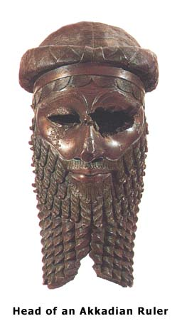
Head of an Akkadian Ruler, 2250-2200 BCE
- From Nineveh, Bronze, life size, hollow cast
- Eyes gauged out, ears broken off, and beard broken off when the king fell from power; eyes gauged out so he couldn't see the divine
- no clear power after the Acadians died out
- Small details and a sense of texture (beard)
- Signs of deliberate mutilation (was attached to a body) for a political statement
- Nonetheless his majestic serenity, dignity and authority are evident
- The sculpture has balanced naturalism and abstract patterning perfectly
- He recoded the distinctive feature of the king with sensual textures
- Overlapping disks of hair and over arching eye brows give character to the portrait; Shows artist's skill at polishing and engraving fine detail
- is the earliest known great monumental work of a hollow cast sculpture
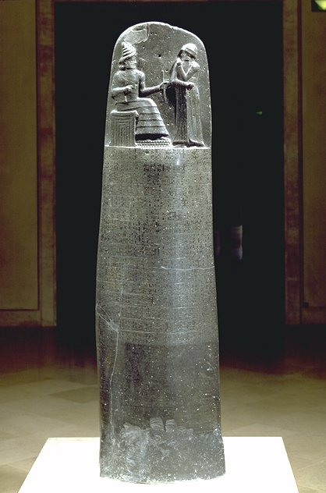
Stele with law code of Hammurabi, Iran, 1780 BCE
- Seven foot four inches
- Hammurabi and Sun god are looking at each other which signifies a transfer of power; he receives inspiration
- Bottom is the entire civil and criminal laws inscribed
- The sun god told him the rules
- Use of tilted profile, transition to pure profile
- Shows a moment of communication
- Hammurabi resestablished a centralized government that ruled southern Mesopotamia; After the fall of the Acadians the ancient near east became very chaotic
- Black basilk
- The bodies are in true profile (see the horns on the sun gods hat) but the shoulders are square outwards
- Exploration of fore shorting and figures expanding into space
- Beard is also diagonal

Ashurbanipal hunting lions (2-24), Iraq, 645-640BCE
- From the north palace in Nineveh Iraq
- Lions are suffering subdued by the army
- Moment captured in time
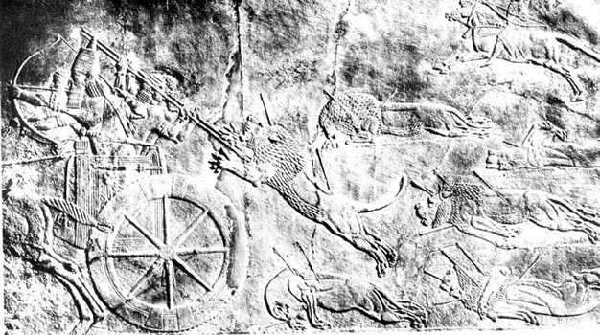
- realistic view with muscle definition, extremely tension, very detailed, swelling veins
- Big contrast to other worked in the period because of the naturalism
- After Banipal was the ruler of the Assyrians
- Open compositions: you can tell that there is more lions around the corner coming; doesn’t just portray what's there
- The artists intention was the glorify the ruler
- faces in pain, twisted dynamic forms
- Was portrayed as an open environment on the wall but the even was in a controlled environment in an arena

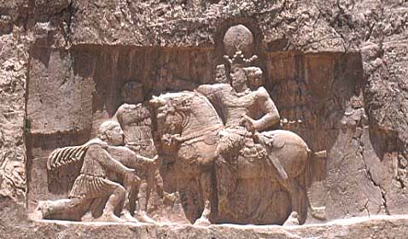
Triumph of Shapur I over Valerian, 260CE, Susanian
- Captured the roman emperor valerian
- Connected to and takes from roman art and expressed that he conquered Romans
- roman visual vocabulary (Valerian kneeling means he's vanquished; cupid)
- A rock cut relief
- distinctive tall Susanian crown
- Crown breaks through the relief border and draws the attention tot he king
- King is larger than life, every one is looking at him
- Crumpled body of a soldier lies under the feet of the course
- Compares to the standard of Ur
- the cupid is to add another level of irony to the roman influence
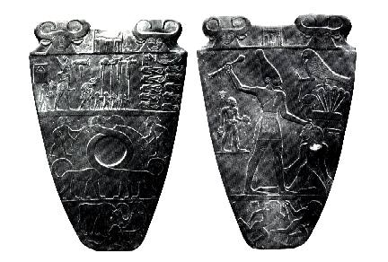
Palate of King Narmer, Pre Dynastic, ca. 3000-2920 BCE, (Egyptian old kingdom)
- Commemorates the joining of upper and lower Egypt
- Narmer wears both crowns on each side
- Stone slab Used to grind eye make up
- Is beating someone to show his power
- King is larger than life
- Earliest existing labelled work of historical art (kartush of Narmer's name)
- Used emerging form of heliogriphics
- Mixed aerial and frontal views in one space
- articulated a visual language for articulating the human figure in profile with frontal eye and torso
- organized the space of the composition in tiers
- Bull on top is goddess Hapur, god Horus is the bird
- Standards, circle in the middle for ceremonial eye makeup
- Repetition of top register with the bulls
- Bulls storming the city
- Looks over everyone he conquered, including decapitated bodies with their heads between their legs
- Three ways the upper and lower Kingdom were united: dykes and damns for nile control, invention of writing to facilitate land administration, organized labour

Imhotep, Stepped Pyramid of Djoser, Early (third) Dynastic, 2630-2611BCE
- The tomb of Djoser
- First pyramid developed from the Mastaba = rectangular tombs
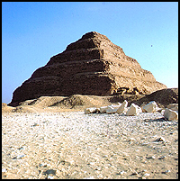
- In the Mastaba small bricks were laid in horizontal courses, in Imhotep's design there is a central core built up with tilted courses around it so that pressure was exerted inwards
- Innovation in architecture
- First known name of an artist in all recorded history
- Pyramids were the t4rue eternal space where lives were just temporary
- Ka needed a hole to travel, blah blah blah...
- Part of the huge temple complex that included a tunnel that lead you to the shining pyramid (importance of entrance ways)

