Dying Warrior (5-27) 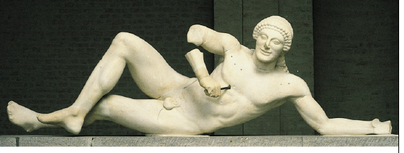
- East pediment, Temple of Aphaia, Aegina
- C.500-490 BCE (Archaic)
- Made of marble, approx. 5’2” long
- torso is rigidly frontal
- stiffness of form
- awkward, almost impossible position
- looks directly at the viewer
- smiles
- stiff, archaic smile, although his chest is punctured by a bronze arrow
- no sense of human feeling, emotion. Mannequin-like.

Dying Warrior (5-28) 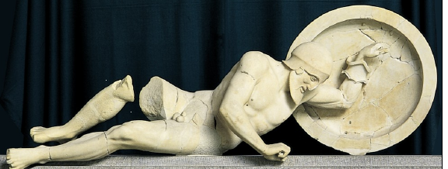
- West pediment, Temple of Aphaia, Aegina
- Made of marble, approx 6’1” long
- C.490-480 BCE (Classical)
- natural posture
- complex angle
- not looking out
- no more rigidity, naturally spaced.
- Torso forward and hips back; sense of torsion (in the relation of hips) and weight
- Figure is appropriate to his condition
- More 3D approach to sculpture
- his reaction to his wound is human – struggles to rise, using his shield for support
- only a decade newer than the Archaic Dying Warrior, however, shows the significance of the radical transition of conception (of what a statue was meant to be) between Archaic and Classical → called the Classical revolution. Archaic – sculptors imposed anatomical patterns on statues from without. Classical – statues move as humans and possess the self-consciousness of real men and women.
Kallikrates & Iktinos - Parthenon (5-42) 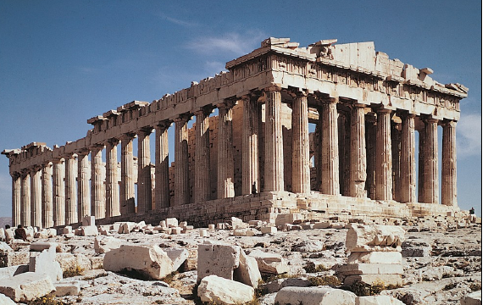
- 447-438 BCE – completed (Classical)
- architects: Kallikrates and Iktinos
- “ideal solution to the Greek architect’s quest for perfect proportions in Doric temple design”
- part of the Acropolis, whose function was to honour Athena (religious monument), and to glorify the city of Athens(statement of power)
- Perikles (leader of the time) placed Phidias, sculptor of the statue of Athena and overseer of sculptural decoration, in control of the project.
- Mathematical refinements: aesthetic appreciation, military suggestions. (harmonious numeral ratios = beautiful proportions)
- Commemorates triumph of the democratic Greek city-states over Persia’s imperial forces (triumph of civilization over barbaric behaviour).
- Imported wood/marble from miles away
- Physically, we are aware of entering a new, grand place (via stairs, gates, doors)
- 8x17 columns → represent “soldiers”, sons of gods
- stylobate curves upward at the center on both the sides and the facade, peristyle columns lean inward slightly, swelling of columns in the middle (entassis) – these adjustments were said to have been made to compensate for optical illusions.
- corner columns slightly closer together = more stability to façade. Other columns well-spaced, slender shafts.
- Front columnade → Doric
- Inner columnade → Ionic. Has a frieze, uninterrupted with metopes.
- Coherent stylistic unity → political/ideological unities

Frieze, Parthenon (5-48) 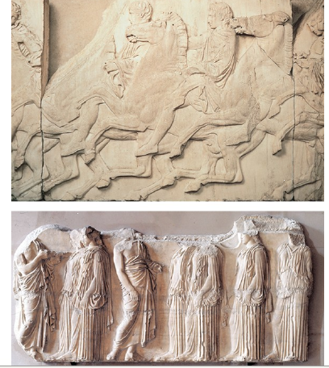 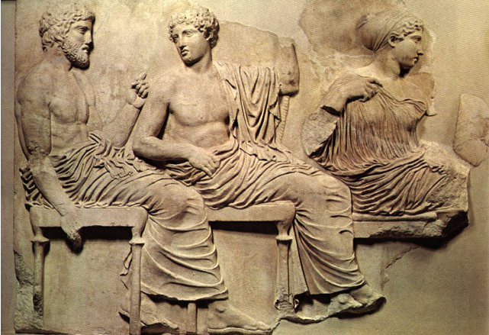
- Horsemen (of north frieze) and seated gods and goddesses (Poseidon, Apollo, Artemis, Aphrodite, Eros) (east frieze), and elders and maidens (east frieze)
- 447-438 BCE (Classical)
- inner Ionic frieze
- shows that Athenians thought very highly of their own worth – judged themselves fit for inclusion in the temple’s sculptural decoration
- upper part of relief is higher than lower part so that the more distant and shaded upper zone is as legible from the ground as the lower part of the frieze.
- made of marble, approx. 3’6” high.
- Subject: Great Panathenaic procession (every 4 years)
- Athenians as healthy, vigorous people enjoying individual rights, but united in a democratic civic body looked upon with favour by the Gods.
- Style: carefully planned rhythmic variations – changes in the speed of the procession
- West side – marshals gather and youths mount their horses
- North and south – cavalcade moves from lower town to Acropolis, accompanied by chariots, musicians, jar carriers, and animals destined for sacrifice
- East – seated gods and goddesses, the invited guests, watch the procession slow almost to a halt near the shrine of Athena’s ancient wooden idol
- Olympian deities are merely spectators – Aphrodite extends her left arm to draw her son Eros’ attention to the Athenians

