Maison Carrée, Nimes (10-30) 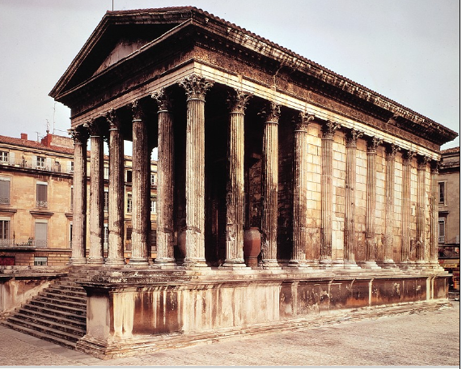
(Not a lot of info in our text/notes, so I did some internet searching)
- c. 20 BCE, (Roman)
- Prototype: Temple of Fortuna Virilis, Rome.
- Said to have been built by Agrippa.
- Many scholars believe that some of the artisans who worked on Fortuna went immediately afterward to Nimes to work on the Maison Carrée.
- Built of local limestone, but without a doubt the architect and workmen came from Rome.
- Shows the allegiance and loyalty of the Roman colony to the imperial dynasty.
- Stands on the short south side of the forum, which it dominates resting on a podium, which is nearly 3 meters (10 feet) high.
- The ratio of short to long sides approaches 1:2 (6:11 columns), and the portico takes up almost a third of the total length.
- Purity of architectural lines, elegance of fluted columns and Corinthian order capitals all have a certain Greek influence.
- Opulent Corinthian order (Rome).
- Post and lintel technique: taken from Greeks.

Colosseum (10-34) 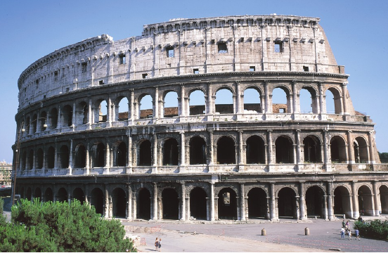

- 72-80 CE, (Roman)
- Under reign of Vespasian (Flavian construction)
- Built on emperor Nero’s gardens on the site of an artificial lake on the grounds, which was drained for the purpose. These once private grounds were reclaimed for the public by Vespasian
- Vespasian died before construction was complete, Titus took over and completed.
- To mark the opening, games were held for 100 days.
- Oval shape and steeply stepped seating: like Greek Amphitheatre (Epidaurus) → but, goes all the way around, not just in a semi-circle.
- Used for mock sea battles (arena was flooded for this purpose), Gladiatorial games, hunts, lavish spectacles…
- Emperors would compete to see who could put on the most elaborate spectacle
- 50,000 capacity, all good views
- 76 exits, passages/stairways throughout
- Series of arches, cross vaults, barrel vaults.
- Arch gave the strength that was needed without making more bulk and weight than was necessary
- Interior: mostly concrete; Exterior: travertine marble
- Use of all three Greek orders (Doric, Ionic, Corinthian) on the exterior façade
- Use of Pilasters (sp?) → flat half-columns → purely for decoration
- Greek decorative tradition with Roman structural competence

Pantheon (10-48, 10-49, 10-50) 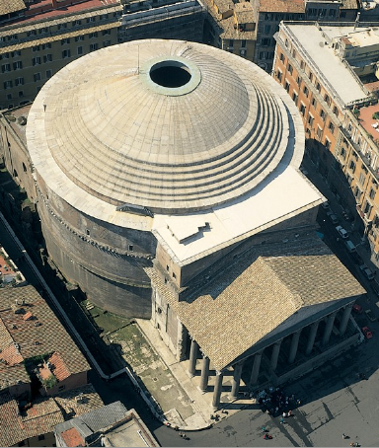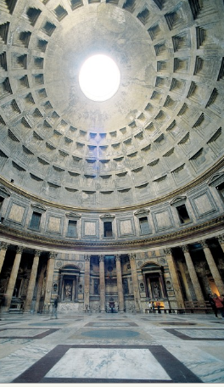

- 125-128 CE, (Roman)
- Construction under the Emperor Hadrian, although dedication states that Agrippa built it
- We know the date because some of the bricks were stamped as being emperor Hadrian’s
- It appears that the columns on the interior support the dome, but it is actually the 8 piers that do this.
- Lower part = heavier concrete, higher = lighter concrete (mixed differently)
- Thickness of dome also decreases as it nears the oculus
- Dedicated to all the gods
- One of the best-preserved buildings of antiquity - because it was used as a church.
- One of the most influential designs in architectural history. (dome 142ft diameter)
- 8 Corinthian columns are a bow to antiquity, everything else was revolutionary.
- Frieze on outside dedicated to predecessor: Marcus Grippus
- Groundplan: Classical porch, round interior covered with a dome
- Interior: support for dome from the wall of the drum and especially the thicker parts of it that function as 8 massive piers (between the columns)
- 8 huge arches built within the cylinder of the drum rest on these piers
- Also materials for concrete different at different levels
- Coffering (square indentations) also lightened the load of the dome. Coffers also get smaller as they get higher, which gives an added sense of distance.
- Wonder of construction and mathematical harmony (height = diameter)
- Oculus (27 ft across): only window in the building, at top of the dome → makes the viewer aware of cosmic forces – (interior space = orb of the earth, dome = vault of the heavens).
- Interior is a whole, uninterrupted by supporting solids → encloses the visitor without imprisoning them
- Light through oculus moves perceptibly around the dome (sense of movement, time, drama, symbolism)

Arch of Constantine (10-76, 10-77) 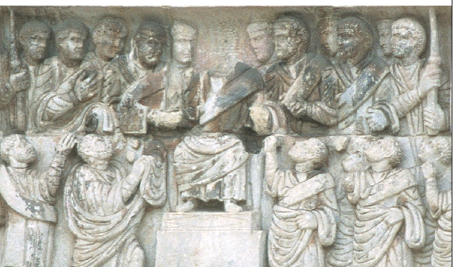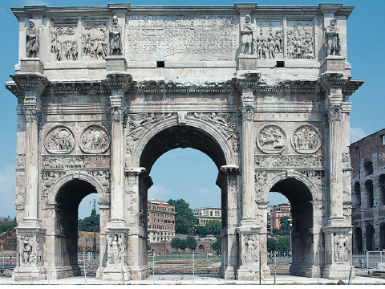

- 312-315 CE (Early Christian)
- Triple passageway arch – largest erected in Rome since a century before.
- Frequently seen in terms of decline of art after antiquity
- Social context: Constantine defeats Maxentius and becomes the first Christian Emperor, took control of the capital.
- Attributed his victory to the aid of the Christian god.
- 313- issued the Edict of Milan, ending the persecution of Christians.
- Named Byzantium the “New Rome”, called Constantinople, Christianity was the official religion of the Roman Empire.
- Triumphal Arch: continuation of tradition
- Use of sculptures from earlier monuments of Hadrian, Trajan, and Marcus Aurelius
- Sculptors refashioned the second-century reliefs to honour Constantine by recutting the heads of the earlier emperors with the features of the new ruler.
- This is seen as evidence of a decline in creativity and technical skill.
- Added labels to reliefs: Fundator Quietus (bringer of peace) and Liberator Urbis (liberator of the city)
- Theme of Arch: “Golden Age”: Emperor as the individual vital to the prosperity of the people
- Constantinian frieze is in a different style: less classical → transition to the medieval world
- Propaganda, situates him within the context of other great leaders → he will continue the prosperity/peace
- Style – emphasizes spiritual concern/dehumanizes
- Relief – shows Constantine with attendants, distributing largess to grateful citizens. He is the frontal, majestic presence, elevated on a throne.
- Figures do not move according to any classical principle of naturalistic movement, but with mechanical and repeated stances and gestures of puppets.
- Shallow relief
- Sculptor depicted a crowd, not a group of individuals
- A picture of actors frozen in time, not a narrative. Rigid formality.

