Guang from Anyang – Shang dynasty China

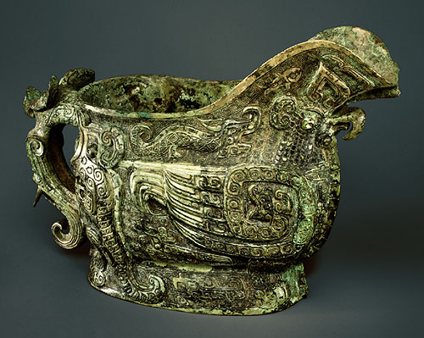
SIMILAR (see 7-2 for exact image)

- Many of vessels produced were used in sacrifices to ancestors and in funerary ceremonies
- Shang bronze held wine, water, grain or meat for sacrificial rites
- Shape matches intented purposes
- Guang = libation vessel shaped like covered gravy boat.
- Display characteristics Shang decorative vocabulary of abstract & animal motifs
- Multiple designs & fields of background spirals integrate closely with form of vessel: not just external embellishment but integral part
- Some motif may represent eye of tiger and horns of ram
- Lid = horned animal, rear = horned head with bird’s beak
- Another horned head on handle
- Fishm birds, elephants, rabbits & more abstract composite creatures all over the work against background of spirals
- Unlikely been purely decorative, but probably connected with world of spirits addressed in the rituals.
Army of the first Emperor of Qin – Qin dynasty China

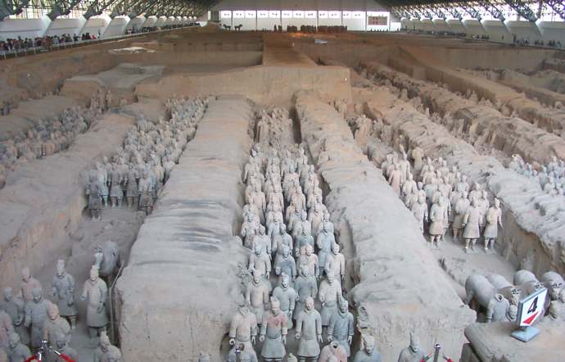
SIMILAR (see 7-5 for exact image)

- 6,000 life-size painted terracotta figures or soldiers and horses, as well as bronze horses and chariots
- Served as immortal imperial bodyguards
- One of 20th century’s greatest archaeological discoveries
- Lesser versions found since at other Chinese sites: suggests First Emperor’s tomb served as model for many others
- Testifies very high degree of organization in Qin imperial workshop
- Employed same molds repeatedly for different parts of statues, but assembled parts in many different combinations.
- Resulted in variation, sometimes slightly, sometimes markedly, from statue to statue
- Result of these efforts is brilliant balance of uniformity and individuality.
Geometric krater, Dipylon cemetery – Greek Geometric

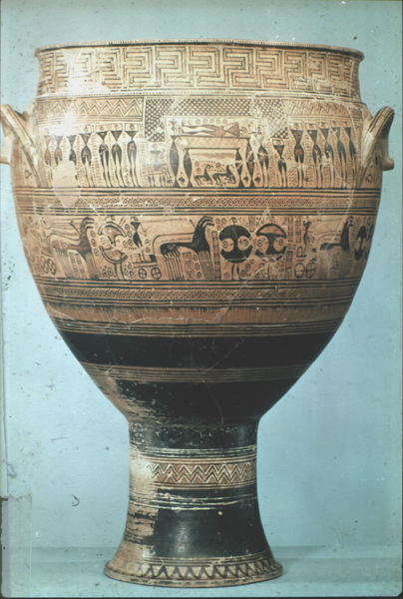
(5-1)

- During 8th century, human figured returned to Greek art; not in monumental statuary but painted on surfaces of ceramic pots
- This krater is one of earliest examples
- Krater = mixing bowl
- Marked grave of an Athenian man buried around 740 BCE
- Over 3 feet tall
- Considerable technique achievement & testifies potter’s skill and to wealth & position of the deceased’s family in the community
- Bottom is open = perhaps permit visitors to grave to pour libations in honour of the dead; perhaps simply provide a drain for rainwater, or both.
- Precisely painted abstract angular motif in horizontal bands
- 2 widest bands reserved for human figures & horse drawn chariots
- Scene depicts mourning for a man laid out on his bier & grand chariot procession in his honour
- No interest in suggesting depth or representing space (funerary couch = 2 legs only)
- Every empty space filled with circles & M-shaped ornaments
- Figures = silhouettes constructed of triangular frontal torsos with profile arms, legs & head (age-old conventions)
- Despite highly conventional manner of representation, marks turning point in history of Greek art: human figures reintroduced & also art of storytelling revived.
Anavysos Kouros – Greek Archaic

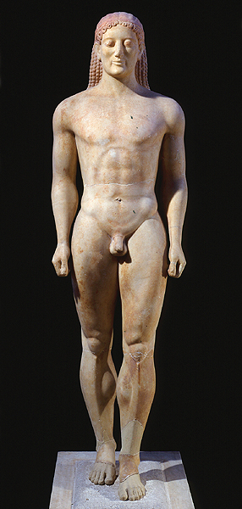
(5-10)

- Young man names Kroisos died a hero’s death in battle
- His grave at Anavysos marked by this kouros
- Inscription invites to mourn at his grave, who died in battle
- Distinctive Archaic smile
- A portrait of specific youth as the New York kouros
- But 2 generations later: style Egyptian stance, but Greek sculptor rendered human body in far more naturalistic manner
- Head no longer too large, face rounder, swelling cheek, hair falls naturally over the back, rounded hips
- Some original paint survives, enhancing sense of life (all Greek stone statues were painted)
- But flesh left color of stone
- Encaustic = technique where pigment mixed with wax applied on statue while still hot

