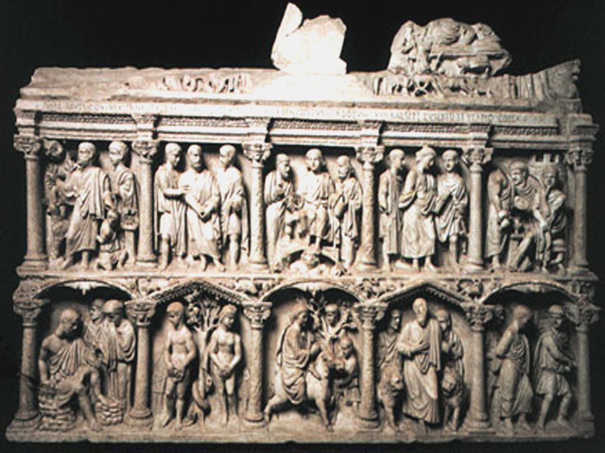
Sarcophagus of Junius Bassus (11-5), Rome, Italy, ca. 359 CE
- made of marble
- was made for a pagan convert to Christianity, baptized a little before his death
- decorated on only three sides in the roman manner
- two registers of five compartments each, framed with columns
- the deceased does not appear on the body of the coffin (different than previous sarcophagi)
- Stories from the New Testament fill the niches: Christ as a teacher, Saint Peter and Paul, Jesus entering Jerusalem on a donkey, etc.
- Christ’s heavenly triumph is situated above his earthly triumph appropriately
- Christ sits like a sky god in his throne holding a blowing mantle over his head…. Owes much to pagan inspiration
- The entrance on the donkey also harkens Roman emperor’s entrance into Rome on horseback
- Old testament scenes were chosen based on their importance to the early church: original sin, Daniel and the lions, Abraham’s sacrifice of Isaac
- No crucifixion but has allusion to it in the judgment of Pontius Pilate frieze

Justinian, Bishop Maximianus and attendants, San Vitale, Ravenna, Italy (12-10), San Vitale, Ravenna, Italy ca. 547CE
- On the choir wall to the north of the apse
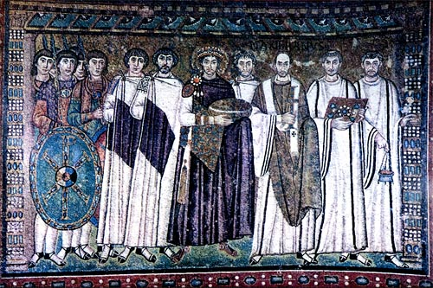
- Justinian has 12 attendants like the 12 apostles
- Mosaic underscores the dual political and religious roles of the Byzantine emperor
- The emperor was the manifestation of the laws of god and had god-given right to rule
- The positions of the figures are very important to understand the status of the characters: Justinian at the center, flanked by the Bishop and possibly the man responsible for the finishing of the Church
- The bishop is also in scripted with his title, which is the only inscription on the mosaic
- Three groups: the emperor and staff, the clergy and the imperial guard
- Soldier’s shield bears the chi-rho-iota monogram of Christ
- Justinian carries a paten (large bowl for Eucharistic bread), which overlaps the bishop’s arm
- Shows the balance between church and ruler
- Was made of mosaic tiles, tilted to catch the light so it would glimmer
- Tesserae (piece of glass/ceramic) put in mortar

Dome of the Rock (13-1, 13-2), Jerusalem, 687-692 CE
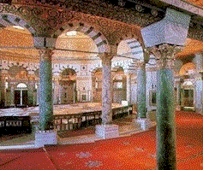
- first great achievement of Islamic architecture in Jerusalem
- Muslims took the city from the Byzantines and built this mosque
- Signified the coming of a new religion to the city
- Textural and plant life decoration
- Calligraphy taking from the Koran
- Golden ceilings
- Built at the end of a turbulent decade where control of Mecca was lost
- A victory monument? Kind of
- Built on a sacred site for all Jews, Christians and Muslims (Abraham’s sacrifice, Solomon’s temple, creation of Adam, ascension of Mohammad)
- Octagon within an octagon surrounding a rock
- Mosaics used to decorate the rock
- External radiance is prominent as well as internal
- Used Byzantine mosaics to decorate the space
- geometric, abstract motifs, extremely lavish, shimmering vale of light and colour
- double shelled wooden dome
- the rock itself is visible in the center of the mosque
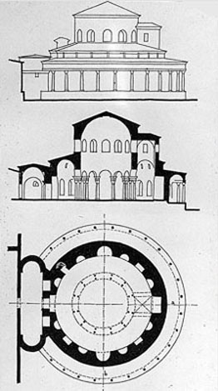
Section and plan of Santa Costanza (11-10), Rome, Italy, ca. 337-351CE
- new type of architectural design
- the building’s part dimensions are equal (or almost) around the center
- usually round or polygonal then
- in the west, central planning was used more for baptisteries and private chapels rather than for large churches
- Santa Costanza is a mausoleum for Costina, the emperor Constantine’s daughter
- The interior includes an ambulatory, a ring like barrel-vaulted corridor separated from the central domed cylinder by a dozen pairs of columns
- Domed
- Was later converted to a catacomb

Christ as Pantokrator, Church of the Dormition, Daphni, Greece (12-21), Daphni, Greece, ca. 1090-1100CE
- Name means literally “ruler of all” but refers in Greek to Christ rule on judgement day
- Climax of elaborate pictorial mosaics
- Is a giant icon that hovers dramatically in space
- It serves to connect the awestruck worshipper in the church below with heaven through Christ
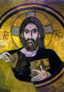
- Common theme in churches in the Byzantine empire
- Located in the monastery of Dormition (means sleep, referring to the ascension of the virgin Mary to heaven at the moment of her death)

Sinan, Mosque of Selim II, Edirne, Interior (13-22), Turkey, 1568-1575CE
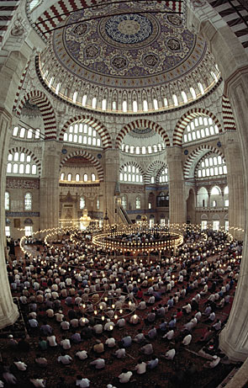
- Erected under a single building campaign under the direction of the single master architect but was often rebuilt and remodelled over the centuries
- Established a centrally planned mosque, Sinan’s efforts to over come the limitations of a segmented interior like other mosques succeeded
- Was built in the location of the capital during the Ottoman empire
- Massive dome offset by four slender pencil shaped minaret (used for the call to prayer)
- Each minaret is more than 200 feet high, among the tallest ever constructed
- Ottoman mosques had numerous annexes including libraries, baths, hospices, etc.
- Architect was born a Christian!
- Preceded by a rectangular court covering an area equal to that of the building
- Porticos formed by the domed squares surround the court yard
- The interior organization recesses into an apselike cove deep enough to permit window illumination making the brightly coloured tiles sparkles
- It is an octagon with a dome roof… ingenious!
- Result? A fluid interpenetration of several geometric volumes that represent a monumental unified interior space
- Height, width and masses are related to one another in a simple ration of 2:1
- Is generally regarded as the climax of the ottoman empire and Sinan’s masterpiece

