Hall of the Bulls, Lascaux Cave
France
Paleolithic (Old Stone Age 15000-1300 BCE)
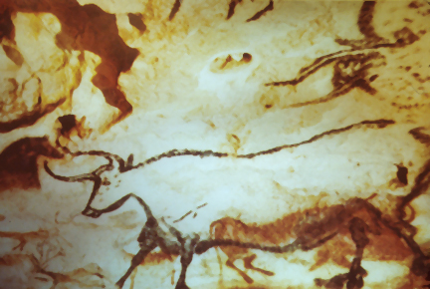

- Best known Paleolithic cave
- Represented using color silhouettes
- Herd of several different animals of various sizes moving
- Bulls are in perspective but horns are seen from front (twisted perspective)

Woman from Willendorf
Old Stone Age (Paleolithic)
2800-2500 BCE
Limestone
- Body parts related to reproduction are enlarged and emphasized
- Not a specific woman but a representation of “womanhood”
- Perhaps used for a child bearing ritual
- Artist didn’t aim for naturalism with shape and form
- Image of fertility

Waterworn pebble, Makapansgat
Old Stone Age (Paleolithic)
3, 000, 000 BCE
- One of the earliest recovered sculptures
- Resembles human face
- From Africa
- Very simplistic/early interpretation of the human face

Indus seal with seated figure
Indus period
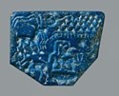
- The figures folded legs and arms resting on kneessuggest a yogic postures
- Suggests that this Indian practice began in Indus civilization

