Title: Pont-du-Gard
Artist: Unknown Roman Engineer
Period: Roman (Early Empire)
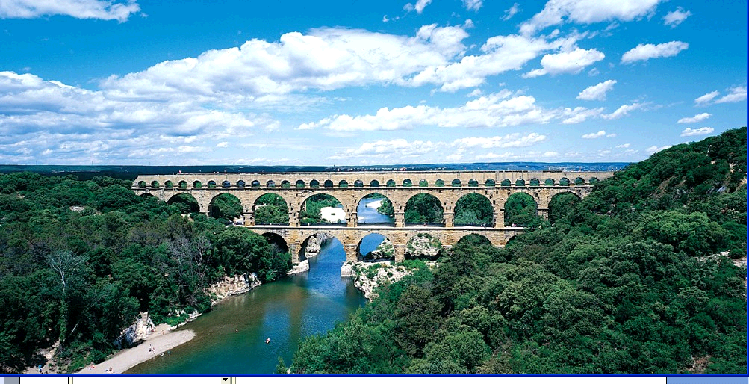
Figure 10-31 Pont-du-Gard, Nimes, France, ca. 16BCE
Facts:
- located in Nimes France
- ca. 16 BCE
- early Augustan project- construction of great aqueduct bridge a.k.a. Pont-du-Gard
- Purpose: carry water from mountain sources to their city on the Tiber River
- Demonstrates skill of Roman engineers
- Provided about 100 gallons of water a day for each inhabitant of Nimes from a source some 30 miles away
- Water carried over considerable distance by gravity flow, which required channels built with a continuous gradual decline over entire route from source to city
- 3 story bridge at Nimes erected to maintain height of water channel where water crossed Gard River
- Each large arch spans 82 feet and is constructed of blocks weighting up to 2 tons each
- Bridge’s uppermost level consists of a row of smaller arches, 3 above each of large openings below
- Quickened rhythm and harmonious proportional relationship between larger and smaller arches reveal that Roman engineer had keen aesthetic, as well as practical, sense.

Title: Arch of Titus
Artist: Domitian (erected by)
Period: Roman (Early Empire)
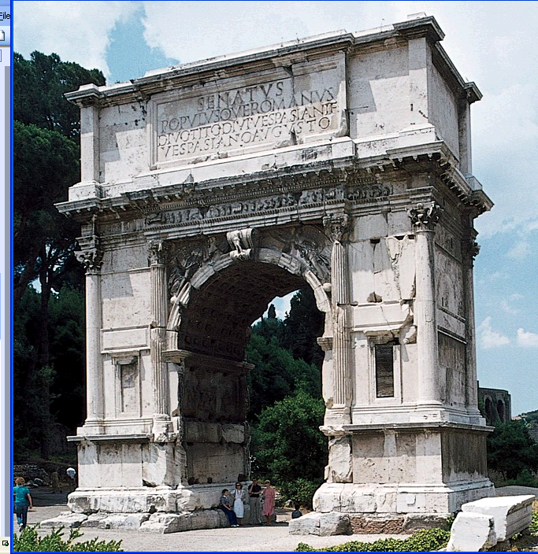
Figure 10-37 Arch of Titus, Rome, Italy, after 81 CE.

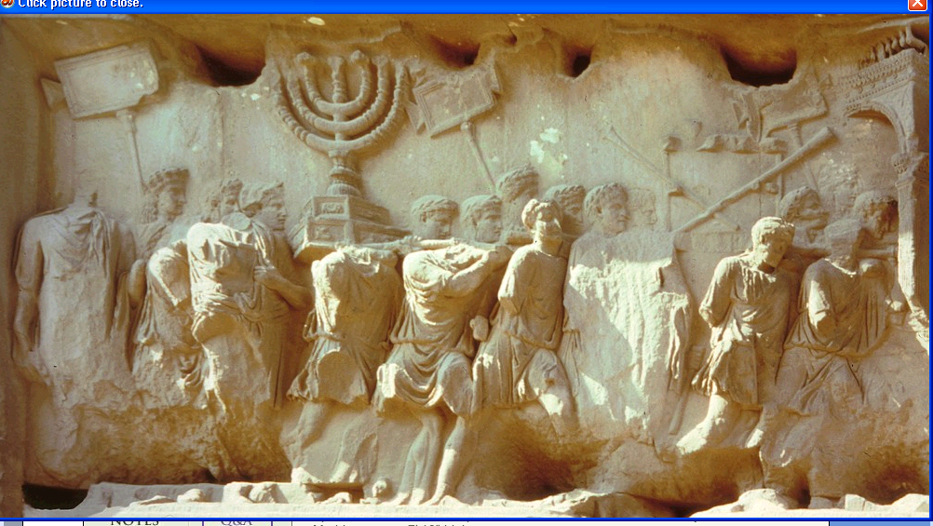
Figure 10-38 Spoils of Jersualem, relief panel from the Arch of Titus, Rome, Italy, after 81 CE. Marble approx. 7’10” High
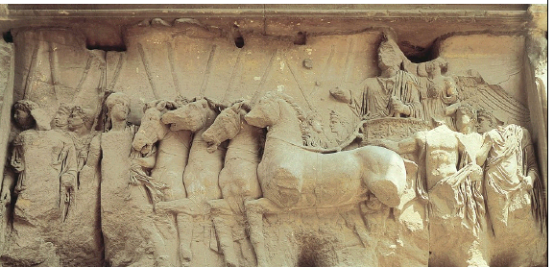
Figure 10-39 Triumph of Titus, relief panel from the Arch of Titus, Rome, Italy, after 81 CE. Marble, approx. 7’ 10” high.

Facts:
- located in Rome, Italy
- after 81 CE
- when Titus died, younger brother Domitian succeeded him and erected arch in his honour on Sacred way leading into Republican Forum Romanum
- TRIUMPHAL ARCH- long history in Roman art and architecture, beginning in 2nd century BCE and continuing even into era of Christian Roman emperors. Misnomer because celebrated more than just military victories. Such free-standing arches usually crowned by gilded bronze statues commemorated a wide variety of events, ranging from victories abroad to building roads and bridges at home
- Typical of early triumphal arches and consists of one passageway only
- Similar to Colosseum – engaged columns frame arcuated opening, but capitals are COMPOSITE type- an ornate combination of Ionic volutes and Corinthian acanthas leaves that became popular at about the same time as 4th Style in Roman painting
- Reliefs depicting personified victories (winged women, as in Greek art) fill SPANDRELS (area between arch’s curve and framing columns and entablature0
- Dedicatory inscription stating that arch was set up to honour god Titus, son of god Vespasian, dominates attic
Roman emperors normally proclaimed gods after they died unless ran afoul of senate- damned; DAMNATIO MEMORIAE torn down – names erased from public inscriptions (ex. Nero)
- 2 great relief panels inside passage way represent triumphal parade of Titus down sacred way after his return from conquest of Judea attend of Jewish wars in 70 CE
- One depicts Roman soldiers carrying spoils –Including sacred 7 branched candelabrum – MENORAH from temple of Jerusalem
- Despite considerable damage to relief- illusion of movement convincing parade moves forward form left background into centre foreground and disappears through obliquely placed arch in right background
- Energy and wing of column of soldiers suggest rapid march
- Contrast- sculptor rejected classicizing low relief of Ara Pacis in favour of extremely deep carving – produces strong shadows
- Heads of forward figures broken off b/c stood free from block
- High relief emphasized different placement ins pace compared to head s in low relief which are in tact
- Play of light and shade across protruding foreground and receding background figures enhances sense of movement
- Panel on other side of passageway shows Titus in his triumphal chariot
- This panel not as accurate; more symbolic- Victory rides with Titus in 4 horse chariot and places wreath on his head
- Below her is bare-chested youth personification of Honor (Honos), female personification of valor (Virtus) leads horses.
- Allegorical figures transform relief form a record of Titus’ battlefield success into celebration of imperial virtues
- Similar intermingling of divine and human figures occurs on Republican Villa of Mysteries Frieze at Pompeii, but Arch of Titus 1st known instance of divine beings interacting with humans on official Roman historical relief
- Erected after emperor’s death and reliefs carved when Titus already considered a god
- Soon afterward interaction between mortals and immortals became staple of Roman narrative relief sculpture even on monuments honoring living emperor

Title: Portrait of Caracalla
Artist: Marcus Aurelius
Period: Roman (Late Empire)
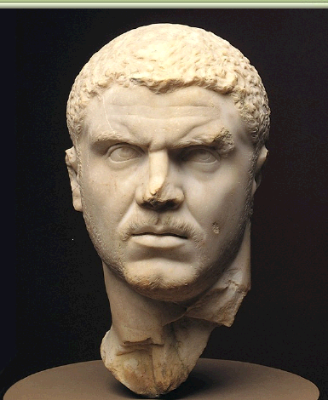
Figure 10-65 Portrait of Caracalla, ca. 211-217 CE. Marble, approx. 1’ 2’’ high. Metropolitan Museum of Art, New York.

Facts:
- made of marble approx. 1’2” high
- ca. 211-271 CE
- located now in Metropolitan Museum of Art, New York
- ex of finest marble portraits
- brilliant suggestion of texture of emperor Caracalla’s short hair and close-cropped beard through deft handling of chisel and incisions into marble surface
- remarkable moving characterization of Caracalla’s suspicious nature; development of introspection in Marcus Aurelius’s portraits
- brow knotted and abruptly turns head over left shoulder as if he suspends danger from behind
- emperor had reason to be fearful; felled by assassin’s dagger in 6th year of rule (assassination fate of many Roman emperors in 3rd century CE)

Title: Interior of the Synagogue at Dura-Europos with wall paintings of Old Testament ` themes
Artist: Unknown
Period: Roman (Late Empire)
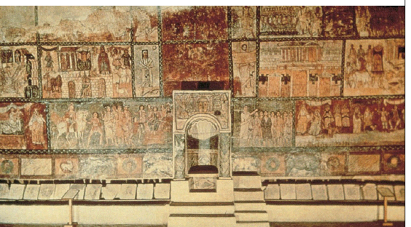
Figure 11-1 Interior of the Synagogue at Dura-Europos, Syria, with wall-paintings of Old Testament themes, ca. 245-256. Tempera on plaster. Reconstruction in National Museum, Damascus.
Facts:
- located in Syria originally, now reconstructed in National Museum, Damascus
- Made of tempera on plaster
- Ca 245-256
- Synagogue at Dura-Europos remarkable not only for existing in Roman garrison town but also for extensive cycle of mural paintings
- Building originally private house converted to a synagogue in latter part of 2nd century
- Painting surprised scholars when first reported because defy Bible’s 2nd commandment prohibiting making of graven images
- Although Jews of Roman empire did not worship idols as did pagan contemporaries, biblical stories appeared on painted walls of synagogues and probably also in painted manuscripts, although no illustrated Bible of period survives
- God (YHWH, or Yahweh in the Old Testament) never appears in Dura paintings except as a hand emerging from top of framed panels
- Dura murals mostly devoid of action, even when subject is narrative theme
- Artists tell stories through stylized gestures and figures which have expressionless features and lack both volume and shadow, tend to stand in frontal rows
- Late Antique Style characteristic of much pagan art in 3rd and 4th centuries including friezes of Arch of Septimius Severus ant Lepcis Magna
- Dura synagogue paintings consistent with major artistic trend in pagan, Jewish and Christian art alike during Late Roman Empire
- Painting of Samuel anointing David exemplifies Late Antique Style
- Depicted on right of niche that housed sacred Jewish Torah (the scroll containing the Pentateuch, the first 5 books for the Hebrew Scriptures)
- Prophet anoint the future king of Israel, while David’s six older brothers look on.
- Painter drew attention to Samuel by depicting him larger than all the rest, a familiar convention of late Antique art
- David and his brothers are emotionless and almost disembodied spiritual presences- Bodies do not even have enough FEET!
- David distinguished form his brothers by purple toga he wears- purple was the colour associated with the Roman emperor
- Dura artist borrowed the imperial toga to signify David’s royalty

